**Data Sheet**

Product: DM-5050PRO

Audio System

Smart Harmony 2-channel 50W Digital Amplifier is small component, efficient, simple and powerful amplifier. Ideal for Professional use and high end multi room application. This unit is also come with one pair line level output to allow further distribution of music or connect to subwoofer. Multi power output selectable and suggested with a 110V/220V switching power supply allow wide world applications and it’s very low power consumption for energy saving. Our professional metal case can prevent interference (EMI) and provide over heat/fire protection. Programmable RS232 and IR interface suitable for any system integration. Optional wall mounting bracket and rack mounting bracket also available for any application’s installation.

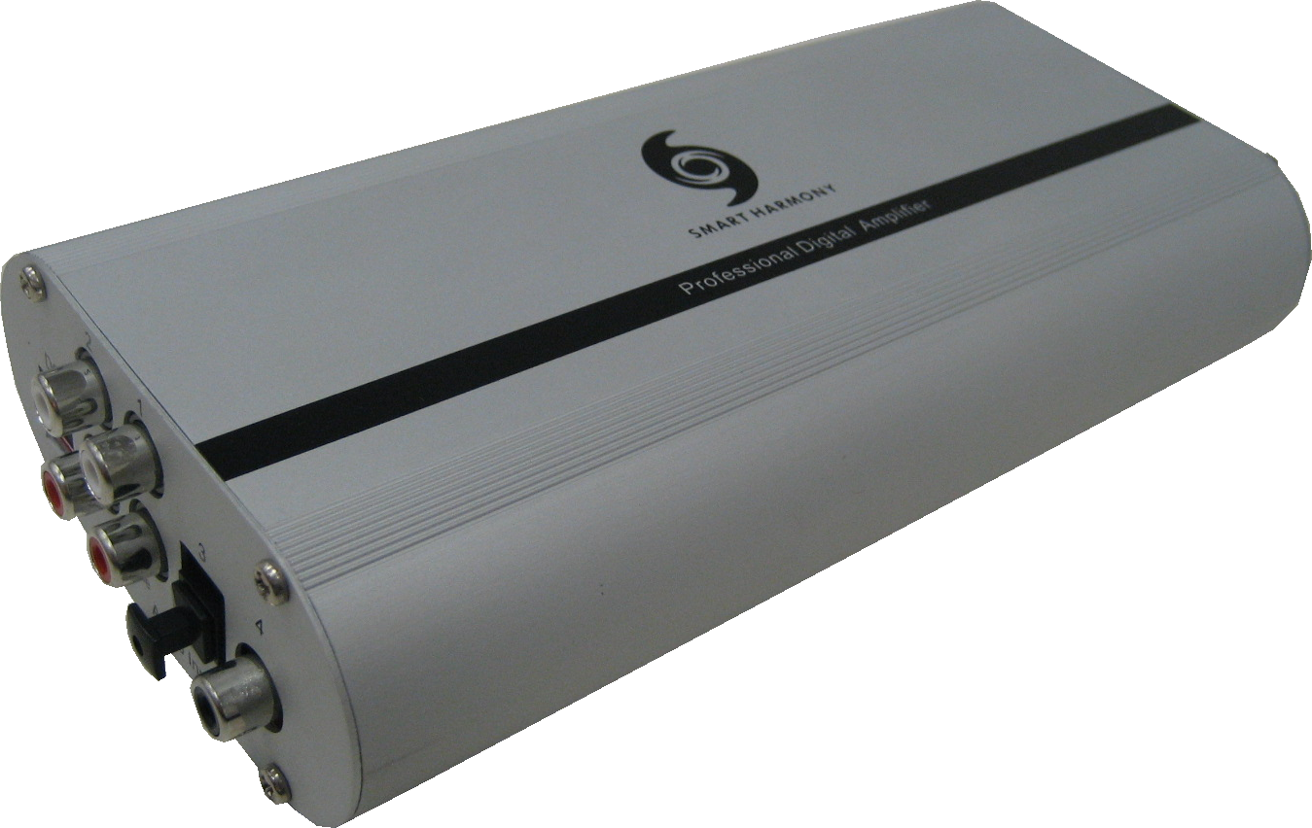

**Cosmetic:**

1. 1mm aluminum front and rear panels
2. Metal case with gray and black color finishing
3. Size: 187mm(W) x 93mm(L) x 40mm(H)
4. Weight: 1.2kg

**Features:**

1. 50W + 50W Output Power
2. SPDIF (Coaxial) Audio Input x 1
3. Optical Audio Input x 1
4. 2 Channel Analogue Audio Input x 2
5. Digital Volume Control Keypad
6. 2 Channel Speaker Level and Line Level output
7. Thermal and Short-Circuit Protection
8. IR and RS232 control interface (DB9-Pin 2,3,5 RS232 and Pin 5,9 IR)
9. Sampling Rate 32kHZ – 96kHz
10. Data Formats: 16, 20, 24 Bit
11. Total harmonic distortion < 0.3%
12. Frequency response: 32kHz - 96kHz ±0.5 dB
13. > 102 dB Dynamic Range
14. 5V Tolerant Input
15. Registering on CE, FCC, RoHS

**Specifications:**

**Connections:**

1. 2 Pair of 2 channels RCA female connector for Analogue Audio input
2. 1 Piece 1 channel RCA female connector for Digital Audio input
3. 1 Piece 1 channel optical connection for Digital Audio input
4. 2 Channel 35W Speaker Level Output (50W Max)
5. 1 Piece of Stereo 3.5mm jack female connector for Analogue Audio Line Level Output
6. Volume Control Keypad connector for remote control
7. DB9 connector for IR and RS232 I/O control interface

**Others:**

Operating Voltage: Operating Range 12V ~ 30V DC

Maximum Input Signal Level: 5Vrms

Maximum Current Consumption: 4A

Quiescent Current Consumption: Max. 50mA

External Dimensions (L x W x H): 187mm x 94mm x 40mm

**Environmental data:**

Operating Temperature Range: -30 ~ +70 °C

Storage Temperature Range: -40 ~ +85 °C