**Data Sheet**

Product: DM-1818

Audio System

Smart Harmony 2-channel 18W Digital Amplifier is a small component, efficient, simple and powerful amplifier. It can be applied for multi-purpose. It is also come with one pair loop through output to allow a short hand application, especially suitable for all kind of analogue and digital playback. This amplifier can provide to both consumer and professional application. Bi-voltage (110V and 220V) switching power supply allows using in different countries and also with low power consumption.

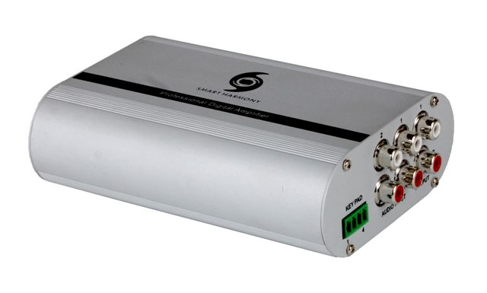

**Cosmetic:**

1. 1mm aluminum front and rear panels
2. Metal case with gray and black color finishing
3. LED indicators for indicating power
4. Size: 132mm(W) x 93mm(L) x 40mm(H)
5. Weight: 0.5kg

**Features:**

1. Class-D Power IC
2. 18W + 18W (MAX) Output Power
3. Electronic Volume Control
4. Thermal and Short-Circuit Protection
5. Audio Input x 2
6. Audio Output x 1 (loop output from Input 1)
7. Stereo / Mono Selection

**Specifications:**

**Electrical:**

1. Input Ports:

RCA input jack (L and R) x 2 pair

DC Power Source Input x 1

1. Output Ports:

RCA loop output jack (L and R) x 1 pair

Speaker output x 1

**Connections:**

1. 2 channels RCA female connector x 2 pairs for Audio input
2. 4 position Phoenix Socket for loudspeaker output

**Electrical specifications:**

1. Maximum Output Power: 18W + 18W / 8 Ohm Loading
2. THD + Noise: < 0.1%
3. Signal to Noise Ratio (A-weighted): > 100dB
4. Frequency Response: 20Hz ~ 20KHz ± 1dB
5. Channel Separation: > 75dB
6. Speaker Load Impedance: 4 Ohm ~ 8 Ohm
7. Noise Floor: < 100uV
8. Supply Ripple Rejection Ratio: > 65dB

**Others:**

1. To be furnished with wired volume button remote control panel with volume level indication
2. Operating Voltage: 10 ~ 15V DC
3. Maximum Input Signal Level: 2Vrms
4. Maximum Current Consumption: 2A
5. Quiescent Current Consumption: Max. 30mA
6. External Dimensions (L x W x H): 132mm x 94mm x 40mm
7. Operating Temperature Range: -30~ 70℃