**Data Sheet**

Product: RWPS-4

Volume Control Keypad

Smart Harmony Keypad, RWPS-4 is special development for our digital amplifier which provides the volume control, channel selection and with flexible customized design. It is designed for hotel, hall, home theater application and etc for easier control the volume control and audio source from our amplifier without re-connecting any cables behind the audio devices. Different artistic and cosmetic keypads can be integrated with interior design

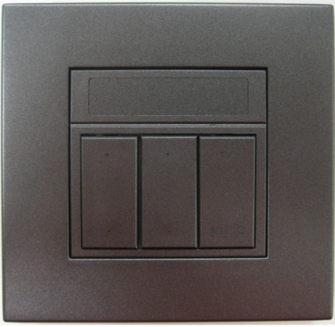

**Features:**

1. Volume Up

Increase the volume by controlling our digital amplifier

1. Volume Down

Decrease the volume by controlling our digital amplifier

1. Source 1 (TV)

Change the audio source to TV

1. Source 2 (Music)

Change the audio source to amplifier

**Cosmetic:**Main Unit Size: 87mm(W) x 87mm(H)

**Specifications:**

* Low supply voltage range at 3V to 3V6
* Operation max power consumption 150mA
* Sound level indication on panel
* Ten controller steps for sound level
* Four buttons controller on panel
* Two buttons for volume digital interface controller
* Two buttons for source control
* Sound terminal voltage output max at 3.3V
* Terminal drain max current at 12mA
* Outlook dimension 87mm x 87mm
* Operating temperature at 0 to 50 ℃