**Data Sheet**

Product: iSBar PRO

Audio System

iSBar PRO is a high grossly frame approach sound bar for the guestroom. The Sound bar equipped a set of high quality drivers together with a Sub bass driver so that guest can enjoy a theater environment. It is good for both music and movie enjoyment. The sound bar system has also remote control function for guestroom automation. Hotel guest only need to use one single remote to navigate the entire system without trouble.



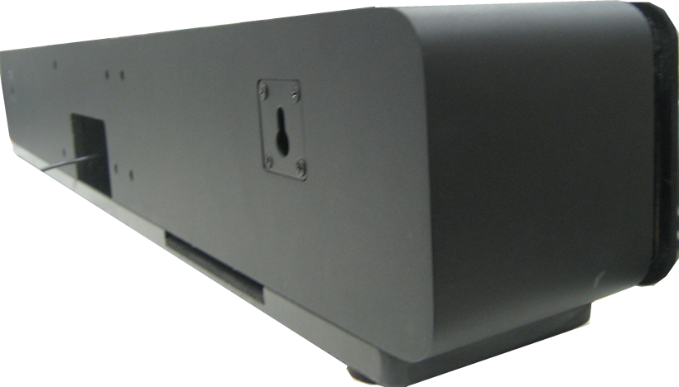**Dimension and Weight:**Custom Length (mm)

T.B.C.

**Specifications: Connections:**

1. 4 set HDMI AV input
2. 1 Set of 3.5mm phone jack for analogue Audio output
3. 1 set of HDMI AV output
4. 2 Channel 35W Speaker Level Output
5. 2 Channel 50W Woofer Level Output

**Others:**

Operating Voltage: Operating Range 210V ~ 230V AC

Maximum Input Signal Level: 5Vrms

External Dimensions (L x W x H):

**Features:**

1. 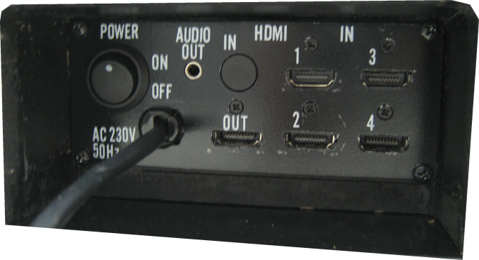35W + 35W Speaker Output Power
2. 50W + 50W Woofer Speaker Output
3. HDMI Input x 4
4. HDMI Video Output x 1
5. Stereo Analogue Audio Output x 1
6. Thermal and Short-Circuit Protection
7. Sampling Rate 32kHZ – 96kHz
8. Data Formats: 16, 20, 24 Bit
9. Total harmonic distortion < 0.3%
10. Frequency response: 32kHz - 96kHz ±0.5 dB
11. > 102 dB Dynamic Range
12. Registering on CE, FCC, RoHS

