**Data Sheet**

Product: IPKP-2

Water Proof Volume Control Keypad

Smart Harmony Water Resistance Keypad, IPKP-2 is special development for our digital amplifier which provides the volume control and with flexible customized design. IPKP-2 is the first keypad which achieved waterproof application with reliable lab test under IPx4 standard. It is designed for washroom, bathroom, swimming pool and kitchen application etc for easier control the volume control and audio source from our amplifier without any electric stock in high humidity and water. Different artistic and cosmetic icons can be integrated with interior design.

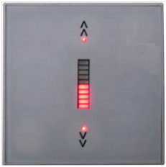

**Features:**

1. Volume Up

Increase the volume by controlling our digital amplifier

1. Volume Down

Decrease the volume by controlling our digital amplifier

1. Volume Indicator

Indicate the volume status

**Cosmetic:**Main Unit Size: 86mm(W) x 86mm(H)

**Specifications:**

* Low supply voltage range at 3V to 3V6
* Operation max power consumption 30mA
* Sound level indication on panel
* Thirty controller steps for sound level
* Two buttons controller on panel
  + Two buttons for volume control
* Sound terminal voltage output max at 3.3V
* Terminal drain max current at 12mA
* Outlook dimension 86mm x 86mm
* Operating temperature at 0 to 50 ℃

**Connections:**

