**Data Sheet**

Product: SH-IRD15

Control System

Smart Harmony IR Multi-channel Distributor, SH-IRD15 is a perfect device for controlling source equipments in long distance. Through build-in IR receiver, users are able to control up to 5 source equipments at the same time. It allows user to control and display the desire source instantly.

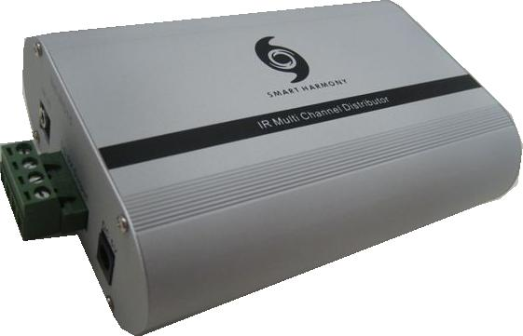

**Cosmetic:**

1. 1mm aluminum front and rear panels
2. Metal case with gray and black color finishing
3. Size: 130mm(W) x 93mm(L) x 40mm(H)
4. Weight: 0.8kg

**Features:**

1. Five (5) outputs are supported
2. Send infrared signal without audio/video signal
3. Using existing remote control without any changes
4. One device only
5. Frequency: 20~60 KHz

**Specifications:**

1. Input Port 1 x IR receiver
2. Output port 5 x IR OUT
3. Power Supply 1 x 5V/500mA DC
4. Dimensions (mm) 93(W) x 40.5(D) x 130(H)
5. Chassis Material Aluminum
6. Silk Skin Color Gray
7. Operating Temperature 0°C ~ 40°C

