**Data Sheet**

Product: SH-HDMIP100

Control System

Smart Harmony starts to deliver new HDMIP100 pair which is a great HD video distribution solution for DOOH and Signage deploy. It delivers stunning Ultra High Quality 1080p HDMI Video broadcast over IP network. Not only does it offer smooth vivid 1080p full motion video with CD quality level audio, but it also ensures that crystal crisp images and sharp small text clarity will give the viewer the maximum visual presenting impact and easy clear reading.

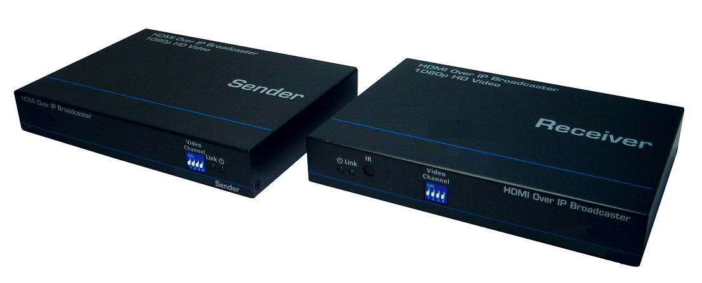

**Features:**

1. 1080p Ultra High Quality Video transmission and Up to 16 Groups Multi-Casting
2. Flexible and scalable HDMI 1080p broadcasting with Gigabit Ethernet LAN
3. 1 to 1, 1 to many & multi-casting broadcasting architecture
4. Multi-Casting group with Gigabit Ethernet managed switch
5. Up to 16 multi-casting group support
6. 16 sets C class IP Dip switch configuration on both Sender & Receiver
7. IR Pass-Thru on 1 to 1 extender configuration

**Specifications:**

HDMI Spec.: 1.3 Compatible

DVI Spec.: 1.0 Compliant

HDCP Spec.: 1.1/ 1.2 Compliant

Sender Connector: Power Adapter in, RJ45, IR Emitter Connector, HDMI

Receiver Connector: Power Adapter in, RJ45, HDMI

Receiver- HDMI Audio Output: Stereo L/R, 16bits, 48Khz

HDMI Video Resolution: 480i/p, 576i/p, 720p, 1080i/p

HDMI PC Resolution: Up to1920x1080 @ 60Hz

Extender Mode CAT5e Length: 100M

Extender Mode: Sender to Receiver by CAT5e/6/7 Cable directly

Broadcaster Mode: Sender to Receiver via LAN

One Sender to Many Receivers

Broadcaster Mode Length: Unlimited within LAN

Operating Temperature: 0-40ºC

Storage Temperature: -20~50ºC

Humidity Range: 5%~90%RH

Power Consumption: 5W

Power Adapter: DC 5V/2A

Material: Metal

Dimension: 165x116x28mm

Product Weight: 325g

