**Data Sheet**

Product: SHC-RCXXX

AV Cables

Smart Harmony offers high-quality RCA interconnect cables pre-terminated in commonly used lengths.

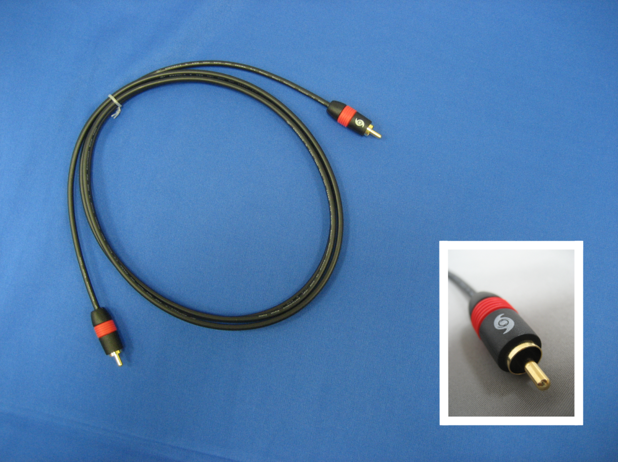

**Cable Length::**Cable Length: 1.0M, 1.5M, 2.0M, 3.0M, 5.0M, 10M, 12M, 15M and 18M

**Specifications:**

|  |  |  |
| --- | --- | --- |
| ITEM | | DESCRIPTION |
| Conductor | AWG | 24 |
| Material | Tinned Copper, Oxide-free |
| Size | 7/0.20mm±0.008mm |
| Insulation | Material | FM-PE+SKIN |
| Outer Diameter | 2.8±0.05mm |
| Spiral Copper | Material | Tinned Copper |
| Coverage | 90% |
| Jacket | Material | PVC |
| Color | Black |
| Outer Diameter | 4.0±0.15mm |

|  |  |
| --- | --- |
| ELECTRICAL CHARACTERISITICS | PHYSICAL PROPERTIES |
| 1. Rating: Temp 80℃ at 30V 2. Conductor Resistance: at 20℃ Max 24AWG: 93.25Ω/km 3. Insulation Resistance: 10mΩ/km min at 20℃, DC 500V 4. Dielectric Strength: AC 500/1 min 5. Coaxial Cable Impedance: 75±5Ωat 10MHz | 1. Tensile Strength:   Unaged: 1500psi min, Aged: 70% min   1. Elongation:   Unaged: 100%, Aged: 65%   1. Heat Shock Test: no cracking 2. Cold Bend Test: no cracking 3. Deformation Test: Max 50% 4. Flame Test: Passed UL VW-1 |