**Data Sheet**

Product: SHC-OPXXX

AV Fiber Optic Cable

Smart Harmony fiber optic cable is designed for audio and video device digital signal transfer application.

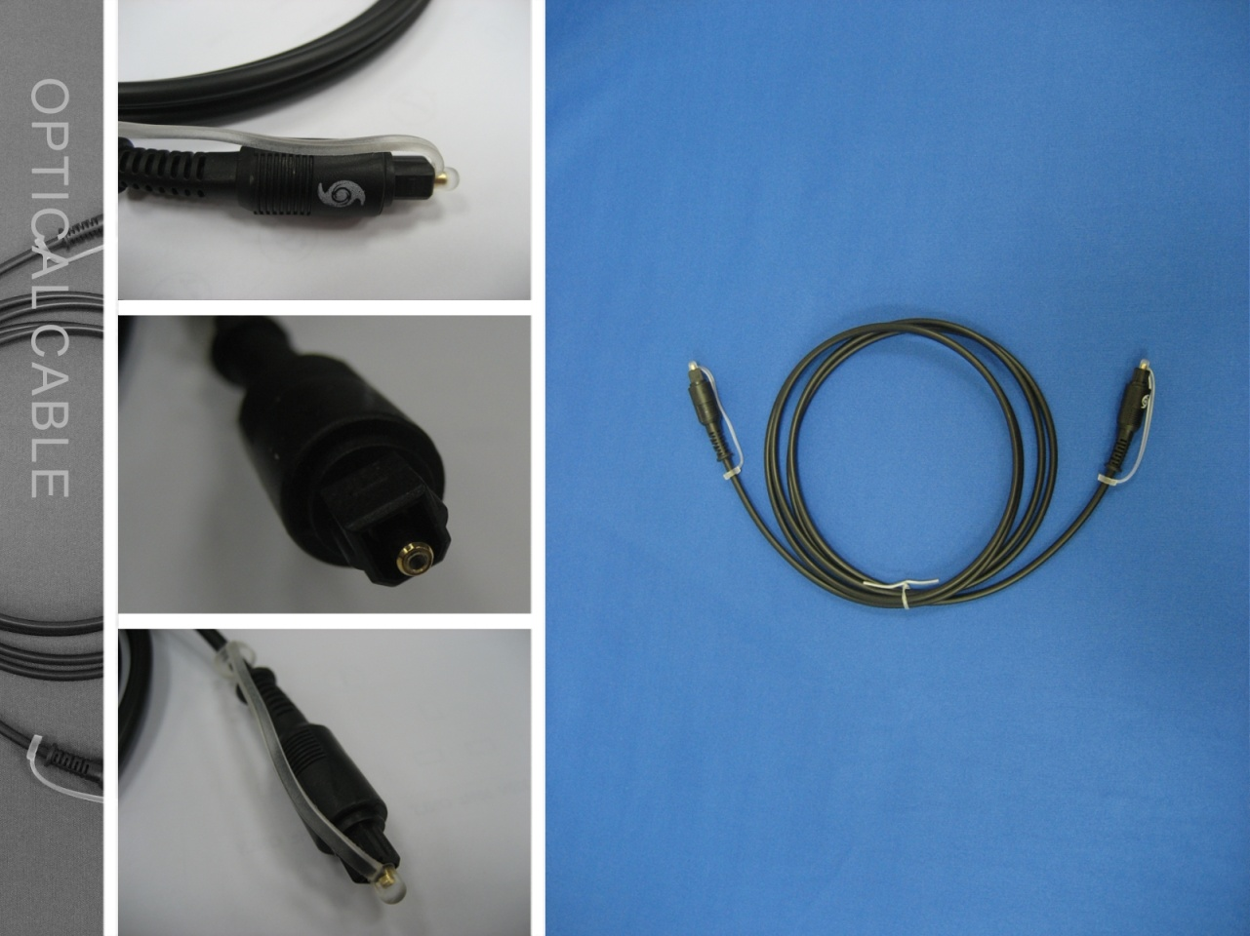

**Cable Length::**Cable Length: 1.0M, 2.0M, 5.0M, 10M, 15M and 18M

**Specifications:**

|  |  |  |
| --- | --- | --- |
| ITEM | | SPECIFICATION |
| CONDUCTOR | MATERIAL | OPTICAL FIBRE |
| OUTER DIAMETER | Φ2.2±0.05mm |
| JACKET | MATERIAL | PVC |
| COLOR | BLACK |
| OUTER DIAMETER | 4.0±0.1mm |