**Data Sheet**

Product: SH-CMC1

Control System

Smart Harmony mini RS232/IR converter is special development on home and hotel application. It is compact in size and competitive on cost help mini converter help to install on any automation project. It’s UDP connectivity allow us to connect with different control equipments, such as keypads and control panels.

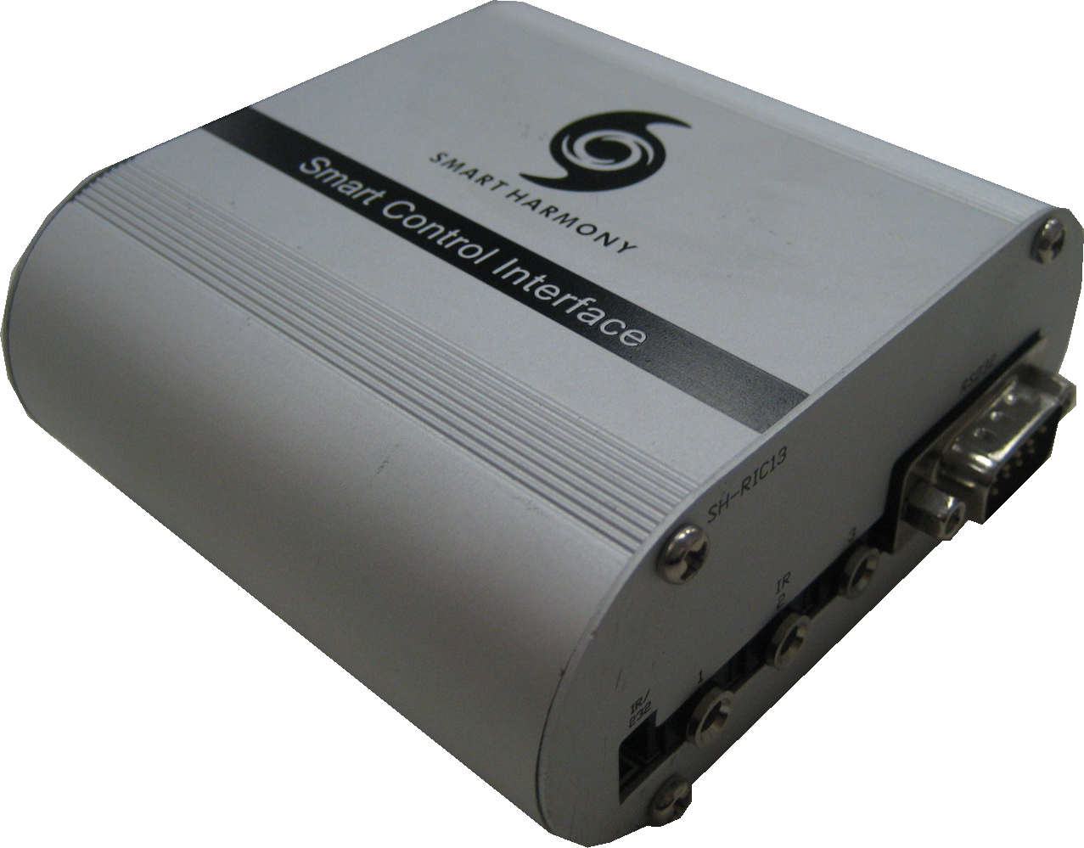

**Cosmetic:**

1. 1mm aluminum front and rear panels
2. Metal case with gray and black color finishing
3. Size: 90mm(W) x 93mm(L) x 40mm(H)
4. Weight: 0.8kg

**Features:**

1. RS232 and IR control input
2. Editable RS232 and IR Command
3. Optional Select on RS232 or IR output
4. RS232/ IR loop out
5. LAN (UDP) control available

**Specifications:**

Connections:

1. RS232 / IR input (RS232 Pin 2,3,5) (IR Pin5, 9)
2. RS232 / IR output (RS232 Pin 2,3,5) (IR Pin5, 9)
3. Optional IR Receiver input (3.5mm phone jack)
4. 3 x RS232/IR Output
5. DC input
6. LAN Connector