**Data Sheet**

Product: SHC-HIXXX

HDMI HI-PQ Cables

Smart Harmony offers High Definition Picture Quality Digital AV (HDMI HI-PQ) Cable cables pre-terminated in commonly used lengths.

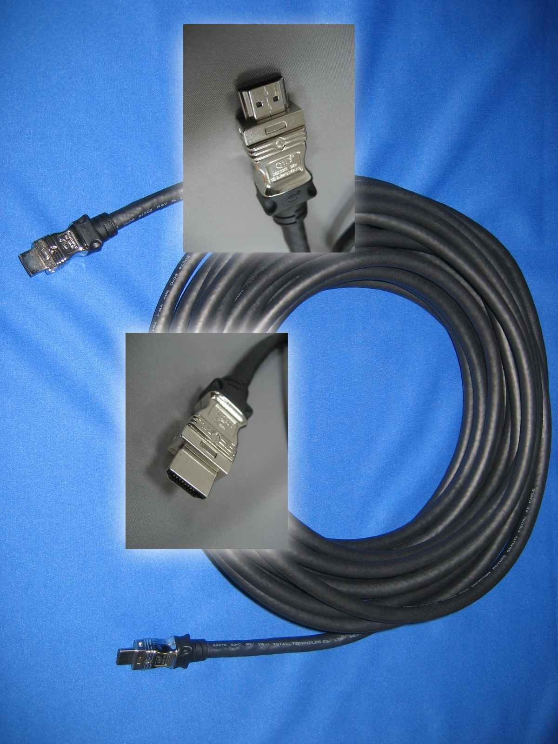

**Cable Length::**

|  |  |
| --- | --- |
| Length | Model |
| 12M | SHC-HI1200 |
| 18M | SHC-HI1800 |

**Specifications:**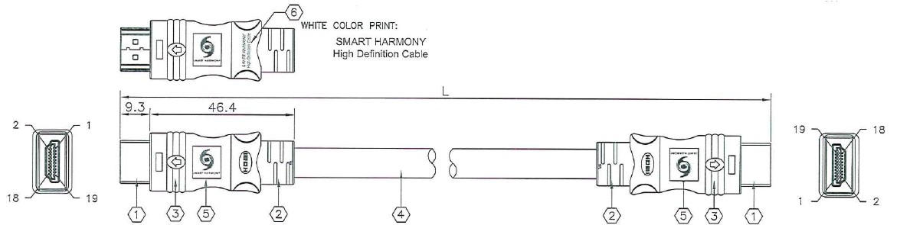

|  |  |  |  |
| --- | --- | --- | --- |
| ITEM | DESCRIPTION | QTY | UNIT |
| 1 | HDMI Type A 19 pin Connector, Male with Gold plated pins, Nickel-plated shell UL94V-0 | 2 | pcs |
| 2 | Black Molded PVC Hood | 2 | pcs |
| 3 | Pat. US 6.287,148 B1 RF-Blok Shielding Metal Can | 2 | pcs |
| 4 | (100Ω Shielding Twisted Pairs) x 4 + 7C wire; AL-foil+85% Braid; Black PVC Jacket | 1 | pcs |
| 5 | D-type Sticker | 4 | pcs |
| 6 | White Color Pad print “SMART HARMONY High Definition Cable” (Optional) | 2 | pcs |

|  |  |
| --- | --- |
| **ELECTRICAL CHARCTERISTICS** | **PHYSICAL PROPERTIES OF JACKET** |
| 1. Rating: Temp 80℃ at 30V 2. Conductor Resistance: 20℃ Max   28AWG: 237.25Ω/km  24AWG: 93.25Ω/km   1. Insulation Resistance:   DC-500V 100mΩ min at 20℃   1. Fext: at 1-5000MHz -26dB Max 2. Impedance: 100±10Ω 3. Attenuation: (5m):  * at 300MHz-825MHz≦8dB/min * at 825MHz-2475MHz=21dB/min * at 2475MHz-4125MHz=30dB/min  1. Time Delay Skew: Intra pair ≦ 151ps 2. Differential Delay: 5.05ns/m | 1. Tensile Strength:  * Unaged: 1500psi min * Aged: 70% min  1. Elongation:  * Unaged: 100% * Aged: 65%  1. Heat Shock Test: no cracking 2. Cold Bend Test: no cracking 3. Deformation Test: min 50% 4. Flame Test: Passed UL VW-1 |



* All materials are RoHS and California PROP.65 compliant lead-free.