**Data Sheet**

Product: SHC-HDXXX

HDMI Cables

Smart Harmony offers high-quality HDMI AV cables pre-terminated in commonly used lengths.

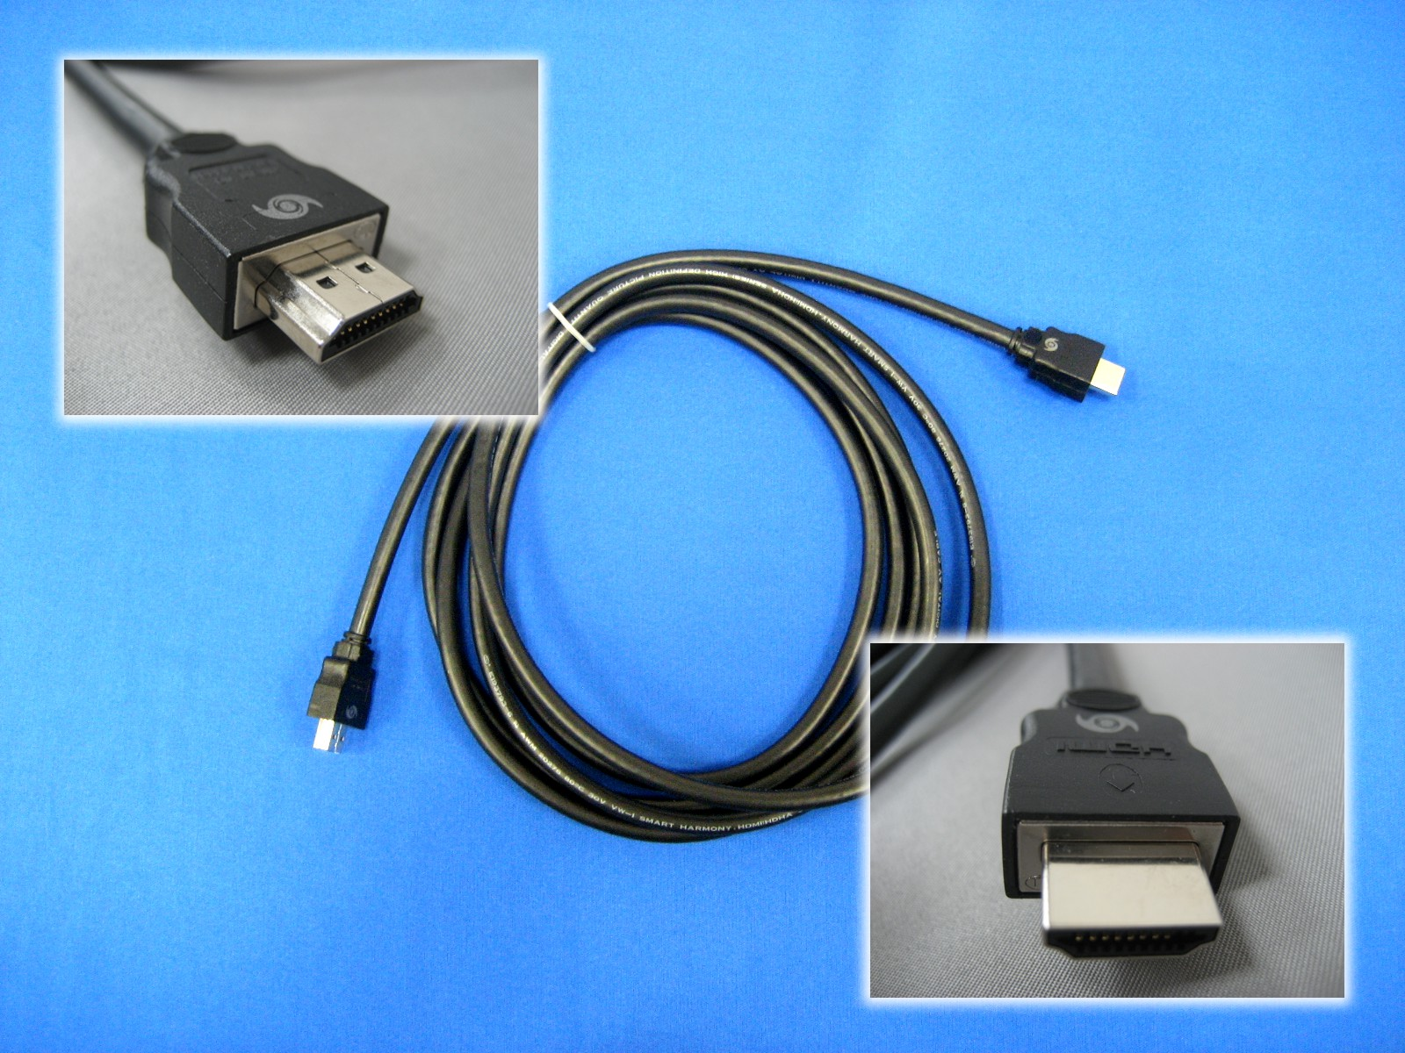

**Cable Length::**

|  |  |
| --- | --- |
| Length | Model |
| 0.5M | SHC-HD0050 |
| 1.0M | SHC-HD0100 |
| 1.5M | SHC-HD0150 |
| 2.0M | SHC-HD0200 |
| 3.0M | SHC-HD0300 |
| 5.0M | SHC-HD0500 |

**Specifications:**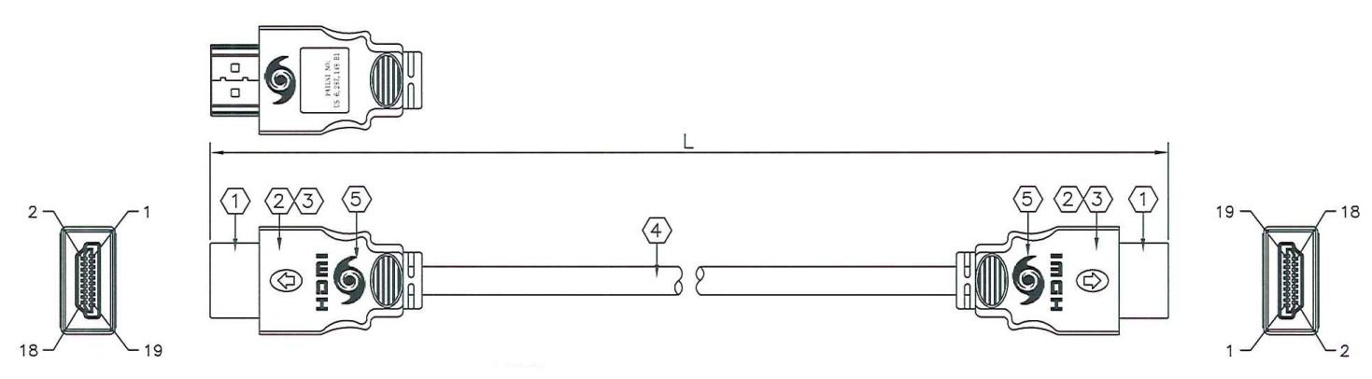

|  |  |  |  |
| --- | --- | --- | --- |
| ITEM | DESCRIPTION | QTY | UNIT |
| 1 | HDMI Type A 19pin Connector, Male with Gold plated pins | 2 | pcs |
| 2 | Black Molded PVC Hood | 2 | pcs |
| 3 | Pat. US 6.287,148 B1 RF-Blok Shielding Metal Can | 2 | pcs |
| 4 | (100Ω Shielding Twisted Pairs) x 4 + 7C wire; AL-foil+85% Braid; Black PVC Jacket | 1 | pcs |
| 5 | Gray Color “Smart Harmony” Silk Screen | 4 | pcs |

COLOR CODE:

|  |  |
| --- | --- |
| (1P+AEM)*4C:   1. White/Red, 2. White/Green 3. White/Brown 4. White/Blue | 7C*28AWG   1. Black 2. Brown 3. Red 4. Orange 5. Yellow 6. White 7. Blue |





Cable Feature

* Lead-free cable
* **HDMI ATC 1.3b CAT1 & CAT2 certified cable**
* Printed “AWM 20276 80℃ 30V VW-1 SMART HARMONY. HDMI (HDMI SERIES) HIGH DEFINITION PICTURE QUANTITY DIGITAL AV CABLE”.

Connector Feature

* Die-cast metal can with PVC hood
* Gold-plated pins
* Nickel-plated connector shell