**Data Sheet**

Product: SH-AGC12

Control System

Audio Gain Controller is a remote control unit on line gain level. It provides two gained output with RS232 and IR control; it especially suitable for controlling the volume of a power amplifier.

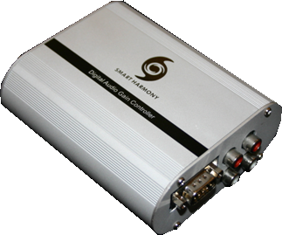

**Cosmetic:**

1. 1mm aluminum front and rear panels
2. Metal case with gray and black color finishing
3. Size: 120mm(W) x 93mm(L) x 40mm(H)
4. Weight: 0.8kg

**Features:**

1. One input and two outputs are supported
2. Three IR RC5 signal for individual selection of the input source; one IR key for power
3. RS232 set baud rate as 9600, 8 bit, no parity bit and 1 stop bit
4. RS232 loop through sending out the same RS232 command that received in the RS232 in port
5. Power supply required the 5V DC in

**Specifications:**Audio

Gain: Unity

Frequency Response: 20 Hz to 20 kHz, ±3 dB

THD + Noise: <0.1% @ 2V out

S/N Ratio: >90 dB “A” WTD re 2V out

Audio Input

Number / Signal Type: 1 / stereo unbalanced

Connectors: 1 pair RCA female (Input 1 to 4)

Impedance: 45k ohms unbalanced

Input coupling: AC

Audio Output

Number / Signal: 2 (buffered) / stereo unbalanced

Impedance: 2200 ohms unbalanced