**Data Sheet**

Product: SH-2000PRO1

Professional HD Media Scaler

SH-2000PRO1 is our brand new product concept for match with today interior design and state of art technology for digital automation device development. This is already the third aux panel products in Smart Harmony family aux panel series. SH-2000ProI is mainly improved the human application, High definition A/V quality and some of the wireless ability. It is designed for today media transition period which allows for many kinds of resolution inputs together with up to date high definition input such as HDMI format and output through only one HDMI cable. And it is also compatible with Apple products.

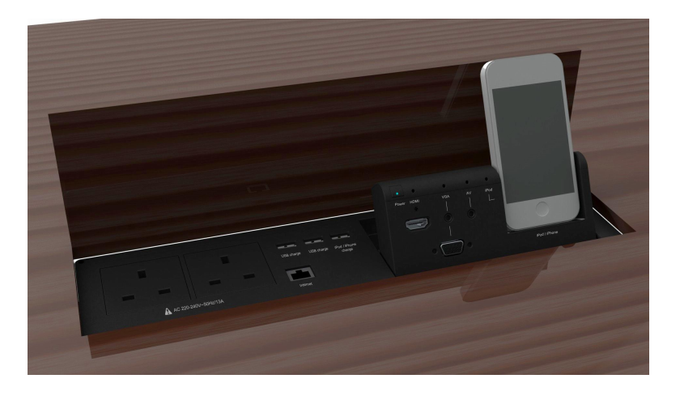

**Cosmetic:**

Aluminum case and cover (about 1.5mm thickness).

Metal case with gray color finishing or any custom color.

Touch key with LED backlight for indicating input selection.

The control and charge panel can be separated to install under the desk top and the main unit can be placed into the desk anywhere for convenience to fit different desks.

Physical Dimension:

Main Unit: 350x97x80

**Specifications:General Specification**

* 5V DC power supply

**Electrical:**

Input Ports:

HDMI x 1

3.5mm Phone Jack with VGA port x 1

3.5mm A/V input x 1

USB socket x 3 for power charging ONLY

Ethernet RJ45 port x 1 bypass jumper

AC Universal Power Socket x 2 (5A, low power consumption)

Apple iPhone / iPod port x 1

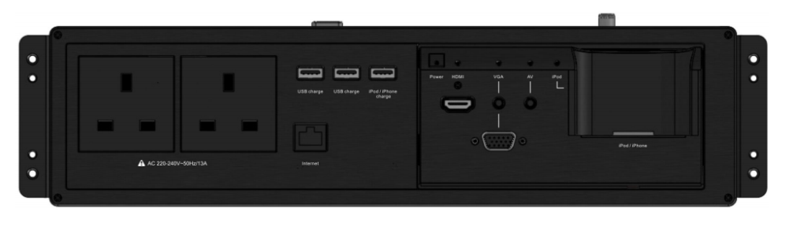Output Ports:

1. HDMI x 1
2. USB socket x 3
3. Ethernet RJ45 socket x 1
4. Coaxial x 1
5. Power Cord for sockets

**Controls:**

RS 232 control port x 1 (for firmware update)

IR input x 1

Manual selector x 1

**Features:**

1. High quality picture output up to:

- HD 1080p; HDMI 1.2,

- HDCP 1.1 and DVI 1.0 compatible with EDID communication.

Manual Switching: Scaling up any PC (VGA ~ WUXGA) /HD (480i ~ 1080p) resolutions

It provides output picture adjustment on contrast, brightness, hue, saturation, sharpness, RGB (color tone) level, and aspect ratio size.

2. Supports high resolution input/output:

PC: VGA, SVGA, XGA, SXGA, UXGA, WXGA, WSXGA, WUXGA

HD Display: 480i, 576i, 480p, 576p, 720p, 1080i, and 1080p.

3. Supports 50/60Hz frame rate conversion.

4. RS 232 programmable for automatic control

5. Optional: DLNA, Bluetooth & Airplay (under development)

6. Optional: Remote control function

7. Optional: Zigbee power control socket and control