**Data Sheet**

Product: SH-1000 PRO II

Professional HD Media Scaler

The Smart Harmony AV Station, SH1000ProII, is designed to be a convenient conduit for all of your guests’ electrical devices, connecting them directly to their Hotel Room TV. It will upscale digital/analogue video signals from Composite, PC and HDMI input sources, to a single digital HDMI output in a wide range of HDTV and PC resolutions, up to 1080p and WUXGA (1920 x 1200). One HDMI cable output will simplify the cable installation and increase cost effectiveness by eliminating multiple output cables. Users can easily select a variety of outputs with LED indicators using the Selector buttons on the front of the panel..

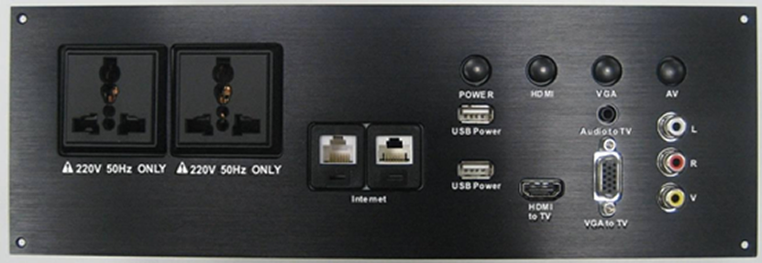

**Features:**

HDMI 1.2, HDCP 1.1 and DVI 1.0 compatible

cales any PC resolutions to/from another PC/HD resolutions

utomatically detect the factory setting

Supports 50/60Hz frame rate conversion

Supports 3-D motion video adaptive

Provides output picture adjustment on contrast, brightness, hue, saturation, sharpness, RGB (color tone) level and aspect ratio size

Supports high resolution input/output:

Supports digital audio output

Manual switching with LED or Backlit indicators

RS-232 programmable automatic control for firmware upgrades and future expansion

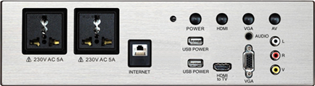



**Cosmetic:**Aluminum panel (from 1.5mm to 2.5mm)Metal case with gray color finishingLED indicators for indicating input selectionSize: 267mm (W) x 91mm (D) x 71mm (H)Weight: 2kg

**Specifications:**1. AC Supply Sockets:Two 220V 5A 50Hz AC universal sockets (CE approved) for connecting any electronic products.2. Power Button with backlit:To press the button to turn ON/OFF the power of the unit, the backlit will be illuminated when the power is turned on.3. HDMI Button with backlit:To press the button to switch into HDMI source, the backlit will illuminate when HDMI source is selected.4. VGA Button with backlit:To press the button to switch into VGA source, the backlit will illuminate when VGA source is selected.5. AV Button with backlit:To press the button to switch into AV source, the backlit will illuminate when AV source is selected.6. Ethernet port:This port is bypass function and connected to LAN port.7. USB ports:Two USB ports for USB power charging.8. HDMI input:To connect the HDMI source into this port, Video and Audio signal can be converted to transfer though the HDMI output port.9. PC video and 3.5 stereo phone jack audio input:To connect the VGA video source and L/R audio into the VGA port and the 3.5mm phone jack port.(It can run separately for only video and audio input.)10. Composite video and L/R audio input:Connect the Composite video and L/R audio port into the Composite RCA jacks.(It can run separately for only video and audio input.)