**Data Sheet**

Product: SH-300 PRO I

Professional HD Media Scaler

The Smart Harmony AV Station, SH300ProI, integrates most connectivity interfaces in the market including Composite Video and Audio, VGA Audio Plug, USB (charge only), etc. This innovative product will easily connect any portable devices with the Hotel Room TV. Hotel guests can easily enjoy their stay with this revolutionary in-room technology.

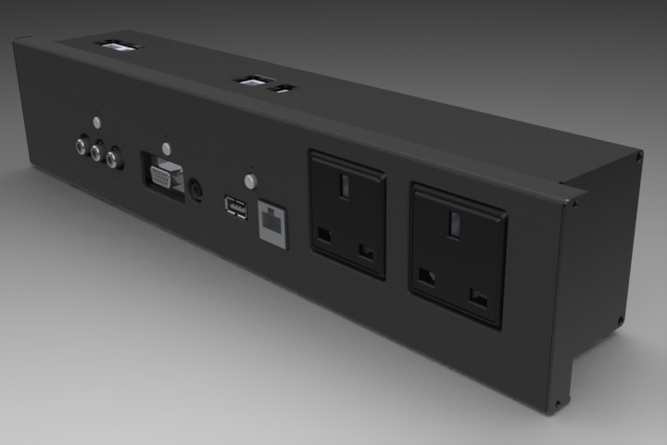

**Features:**

* Able to transfer analog signal to digital signal, and upscale the resolution to 1080p
* Cat. X output solution which is designed to apply on the long distance signal transmission
* VGA input supports resolution up to 1280 x 1024 in SXGA
* USB interface is designed for charging purpose
* RJ45 interface is designed for Internet communication
* 3.5mm stereo audio input jack is for MP3 player or PC audio

**Cosmetic:**Unit Size: 352mm(W) x 60mm(D) x 65mm(H)Panel Size: 382mm(W) x 12mm(T) x 88mm(H)

**Specifications:**- Composite Input: for connecting AV equipment; it can run separately for only video and audio input.- PC Video Input: for connecting the VGA video source- 3.5 Audio Input: for connecting left and right audio channel - USB Power: for power charging of electronic devices- Network Port: for Internet connection- Power Button with Backlight: To press the button to turn ON/OFF the power of the unit, the backlit will be illuminated when the power is turned on.- VGA Button with Backlight: To press the button to switch into VGA source, the backlight will be illuminated when VGA source is selected.- AV Button with Backlight: To press the button to switch into AV source, the backlight will be illuminated when AV source is selected.