**Data Sheet**

Product: SH-500 PRO I

Professional HD Media Scaler

The Smart Harmony AV Station, SH500ProI, integrates most connectivity interfaces in the market including HDMI, iPod / iPhone, Composite, VGA Audio Plug, USB (charge only), etc. This innovative product will easily connect any portable devices with the Hotel Room TV. Hotel guests can easily enjoy their stay with this revolutionary in-room technology.

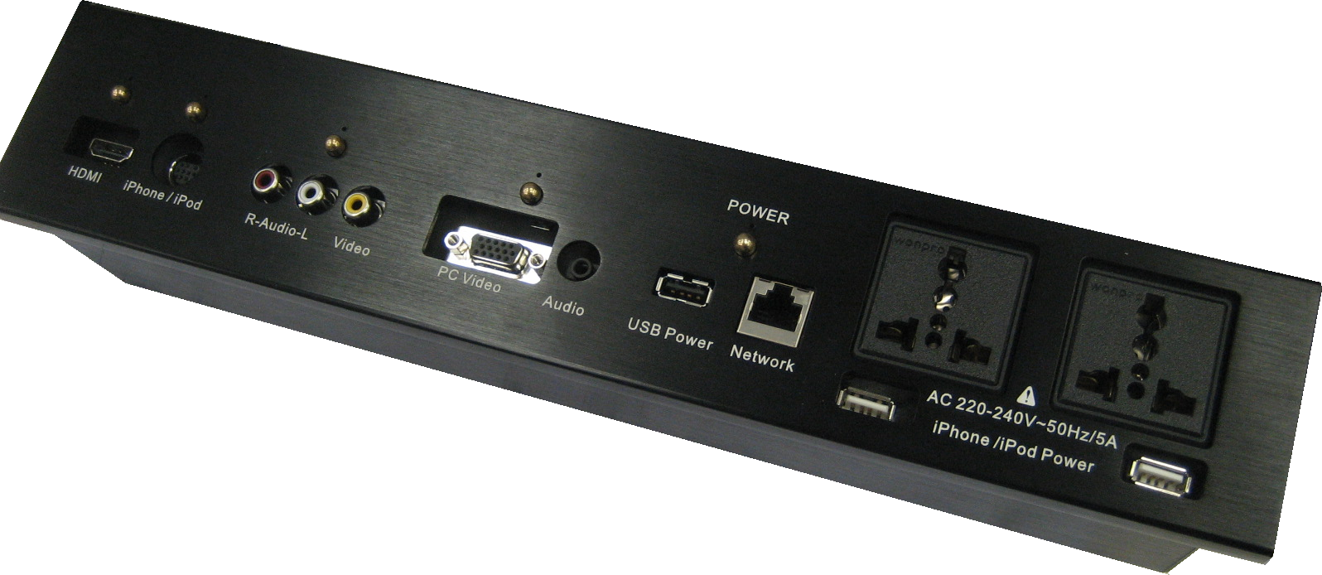

**Features:**

* Unique iPod/iPhone interface is with up scaling function which delivers image and sound in the high quality to the in-room HDTV
* Able to transfer analog signal to digital signal, and upscale the resolution to 1080p
* Cat. X output solution which is designed to apply on the long distance signal transmission
* The audio of each S-Video and Composite are independent
* HDMI input supports 12 bit deep color 1920 x 1080p
* VGA input supports resolution up to 1280 x 1024 in SXGA
* USB interface is designed for charging purpose
* RJ45 interface is designed for Internet communication
* 3.5mm stereo audio input jack is for MP3 player or PC audio

**Cosmetic:**Main Unit Size: 346mm (W) x 58mm (D) x 67.5mm (H)Panel Size of Main Unit: 372mm (W) x 12mm (D) x 72mm (H)

Opening Size: 346mm x 67.5mm

Fixing base material thickness <= 15mm

Access behind for installation and maintenance

**Specifications:**- HDMI Input: for connecting HDMI source- iPod / iPhone Input: for connecting iPod / iPhone to this port with provided cable- Composite Input: for connecting AV equipment; it can run separately for only video and audio input.- PC Video Input: for connecting the VGA video source- 3.5 Audio Input: for connecting left and right audio channel - USB Power: for power charging of electronic devices- Network Port: for Internet connection- Power Button with Backlight: To press the button to turn ON/OFF the power of the unit, the backlit will be illuminated when the power is turned on.- VGA Button with Backlight: To press the button to switch into VGA source, the backlight will be illuminated when VGA source is selected.- AV Button with Backlight: To press the button to switch into AV source, the backlight will be illuminated when AV source is selected.- iPod / iPhone Button with Backlight: To press the button to switch into iPod / iPhone source, the backlight will be illuminated when AV source is selected.- HDMI Button with Backlight: To press the button to switch into HDMI source, the backlight will be illuminated when HDMI source is selected.

* Fully support on 800x600, 1280x768 and 1280x1024 VGA resolution